Project Design Phase-II
Data Flow Diagram & User Stories
WasteGuide AI — Sustainable Waste Management Assistant
A Data Flow Diagram (DFD) is a visual representation of the information flows within a system — it shows how data enters and leaves the system, what changes the information, and where data is stored.

Data Flow Diagram — Level 1
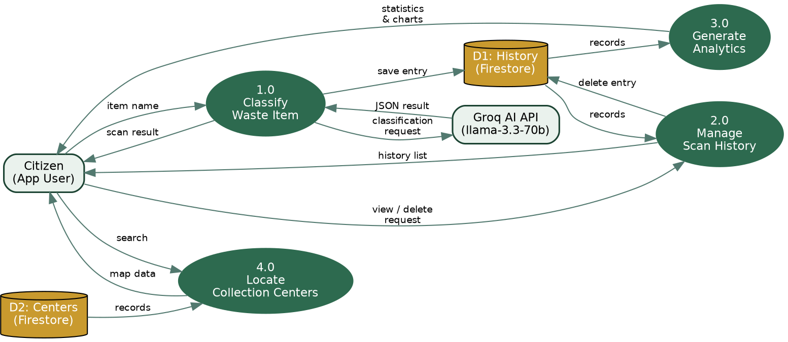

User Stories
The table below lists the user stories driving WasteGuide AI's functional requirements.
User Type | Functional Requirement (Epic) | User Story No. | User Story / Task | Acceptance criteria | Priority | Release
Citizen (App User) | Waste Item Classification | USN-1 | As a user, I can type any waste item and get its category, recyclability, and hazard level. | I receive a classified result within seconds of clicking Scan. | High | Sprint-1
Citizen (App User) | Waste Item Classification | USN-2 | As a user, I can see step-by-step disposal and recycling instructions for the scanned item. | Disposal and recycling steps are shown as a numbered list on the result card. | High | Sprint-1
Citizen (App User) | Waste Item Classification | USN-3 | As a user, I can see a hazard warning if the item is dangerous to handle. | A red hazard banner appears when hazard level is Medium or High. | Medium | Sprint-1
Citizen (App User) | Scan History | USN-4 | As a user, I can view, search, filter, and sort my past scans. | History page returns matching, correctly sorted, paginated results. | High | Sprint-2
Citizen (App User) | Scan History | USN-5 | As a user, I can delete a scan I no longer want in my history. | Deleted entry disappears from the list and does not reappear on reload. | Medium | Sprint-2
Citizen (App User) | Analytics Dashboard | USN-6 | As a user, I can view charts summarizing my recycling habits. | Dashboard shows doughnut, bar, line, and pie charts reflecting my real scan data. | Medium | Sprint-2
Citizen (App User) | Center Locator | USN-7 | As a user, I can find nearby waste collection centers on a map. | Map shows color-coded markers with address, hours, and accepted waste on tap. | High | Sprint-2
Administrator | Center Management | USN-8 | As an administrator, I can maintain the list of collection centers shown to users. | Center records (name, location, accepted waste) can be added or updated in Firestore. | Low | Sprint-3
System (AI Service) | Waste Item Classification | USN-9 | As the system, I must validate and normalize the AI's JSON response before saving it. | Any malformed or out-of-schema AI response is corrected or rejected, never stored as-is. | High | Sprint-1

